CRM Application for Jewel Management (Developer)

**College Name**: Kumaraguru College of Arts and Science

**College Code**: bruax

**Team ID :** NM2025TMID25560

**Team Size :** 4

**Team Leader : Hari Prakash K**

**Email:hariprakash.23bds@kclas.ac.in**

**Team member :** Abiram P

**Email: abiram.23bds@kclas.ac.in**

**Team member :** Ritissh D S

**Email** : **ritissh.23bds@kclas.ac.in**

**Team member :** Santhna K

**Email** : **santhna.23bds@kclas.ac.in**

INTRODUCTION :

The Jewel Inventory System is a comprehensive software Solution designed to streamline and manage the inventory and sales processes of a jewellery store or a jewellery manufacturer. The system aims to provide an efficient and user-friendly solution to track and control the inventory of various jewellery items, maintain accurate records, and facilitate seamless sales transactions.

DEVELOPMENT PHASE :

**Creating Developer Account: By using this URL** [**-**](https://www.salesforce.com/form/developer-signup/?d=pb)<https://developer.salesforce.com/signup>

Create Jewel Customer Object :

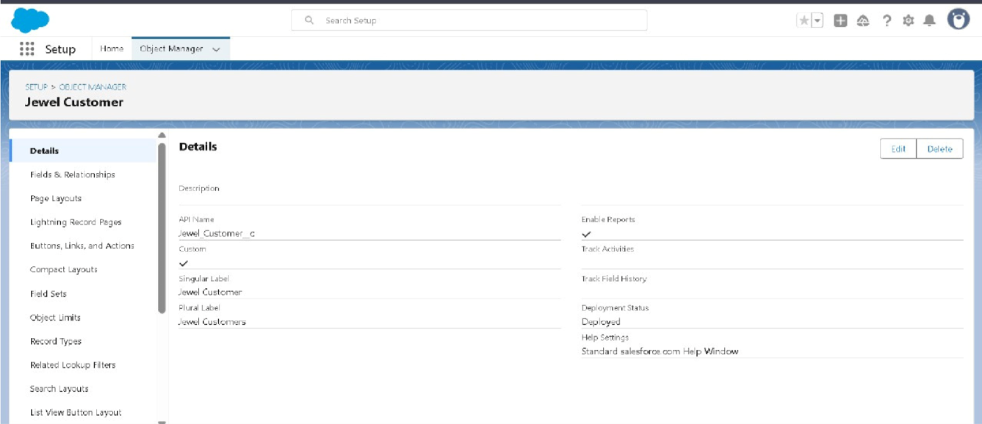

Create Objects - Item , Customer Order , Price , Billing :

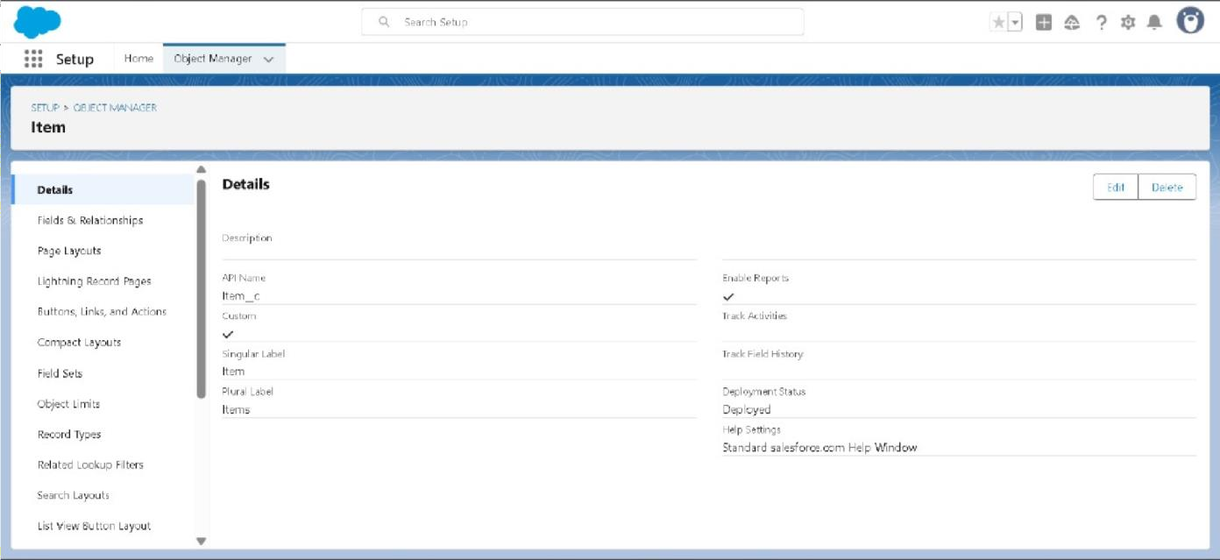

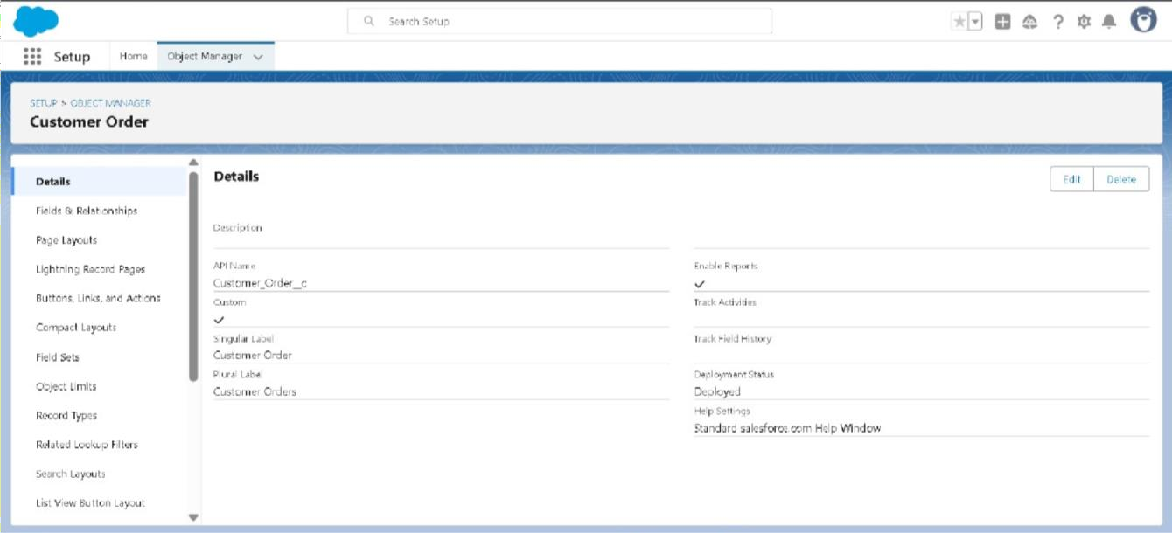

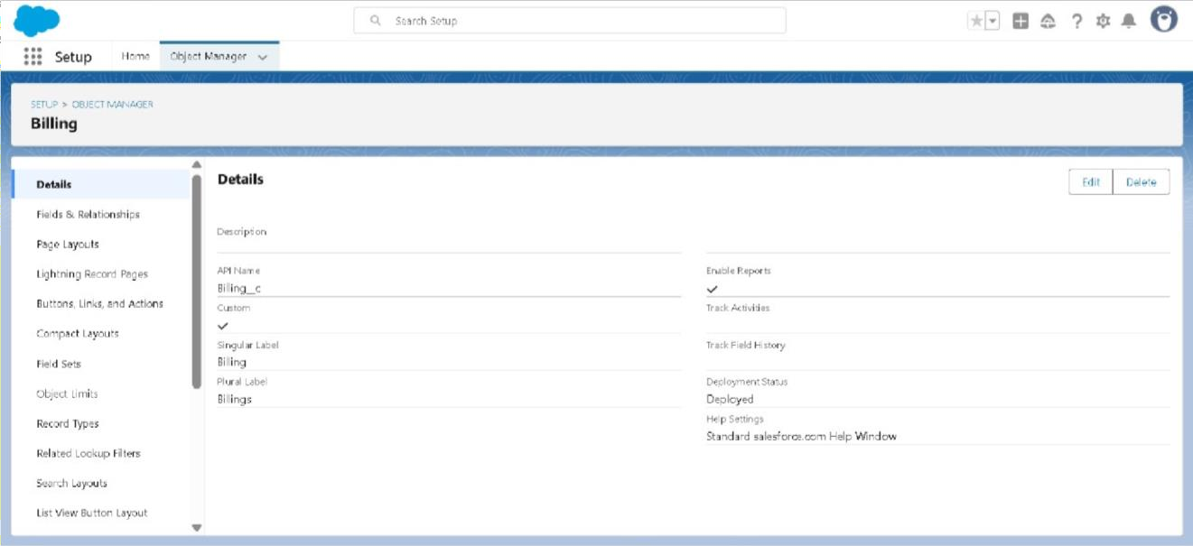

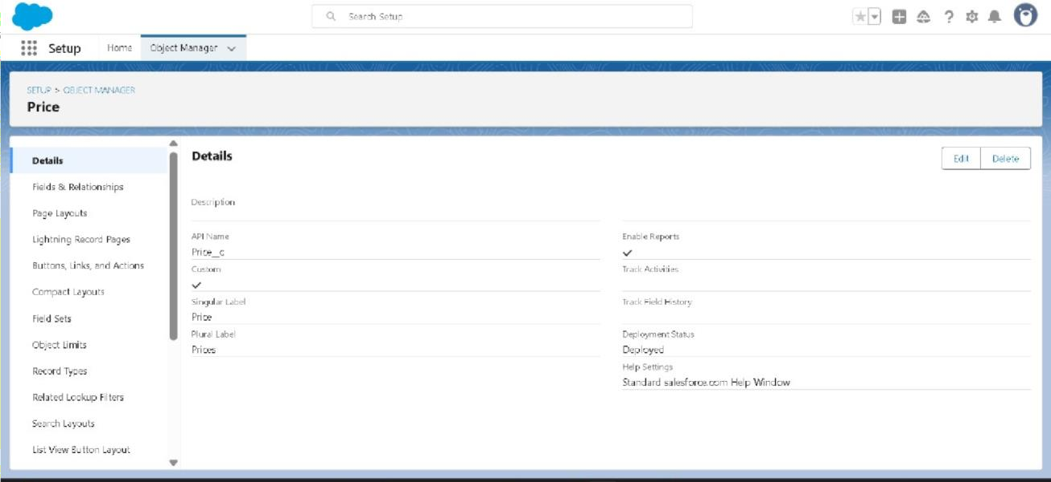

To Create a Tab- Item , Customer Order , Price , Billing Objects :

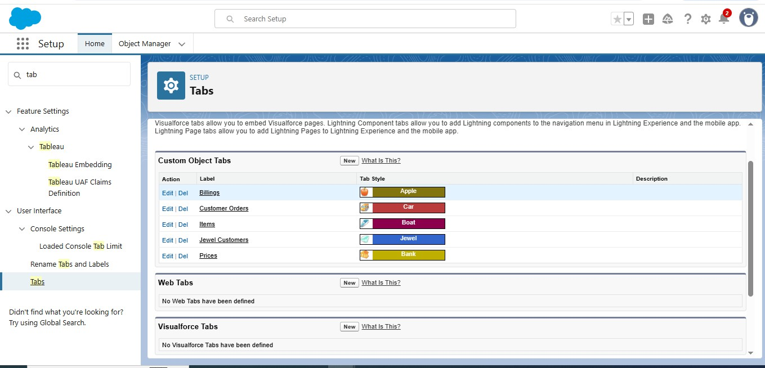

Create a Lightning App - Jewellery Inventory System :

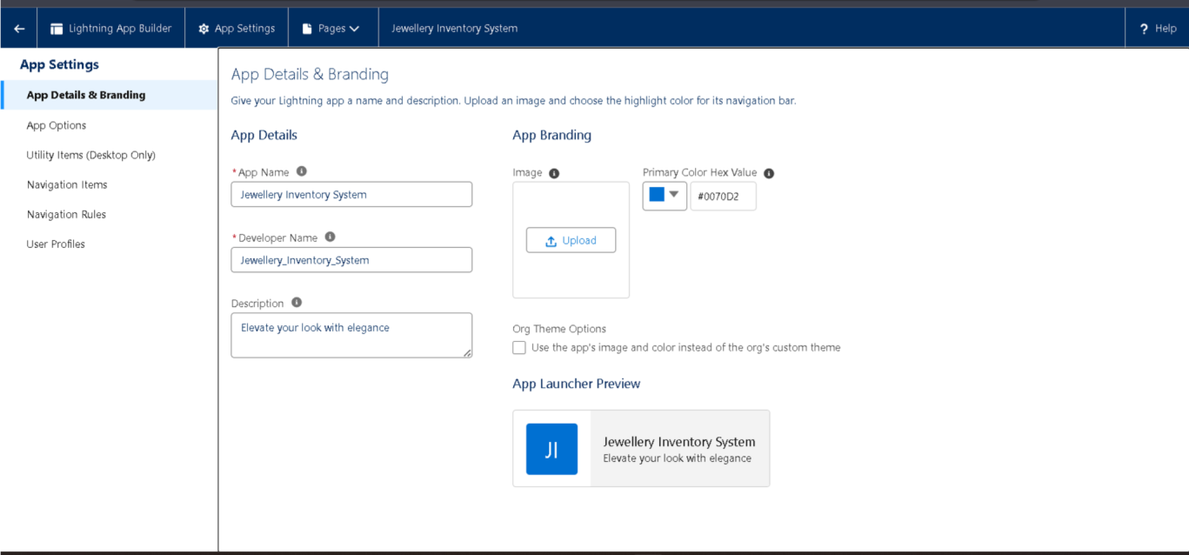

Creating Lookup Relationship - Customer :

Creating a Master-Detail Relationship - Item :

Creating Text Field , Phone , Email in Jewel Customer Object :

Creating the number,Picklist fields in Item object :

Creating Formula Field (Cross Object) in Item Object :

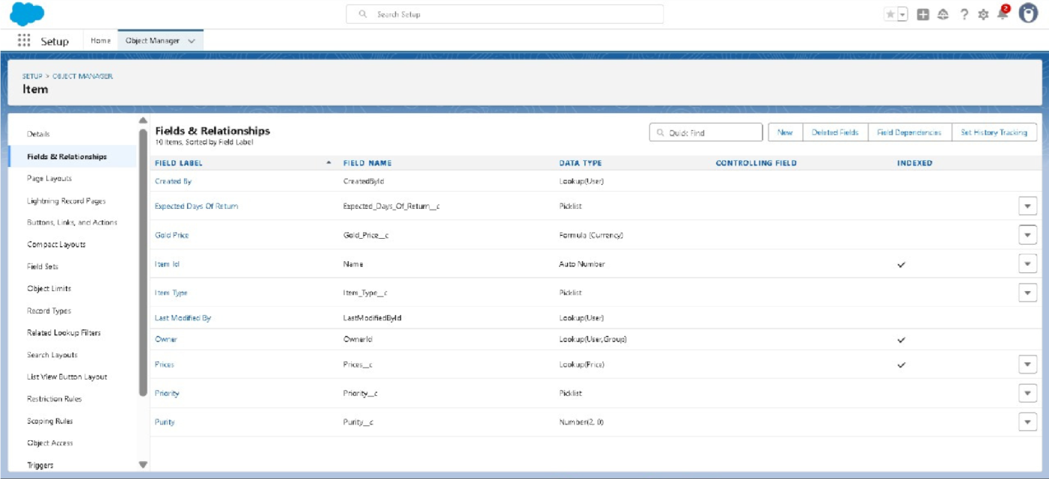

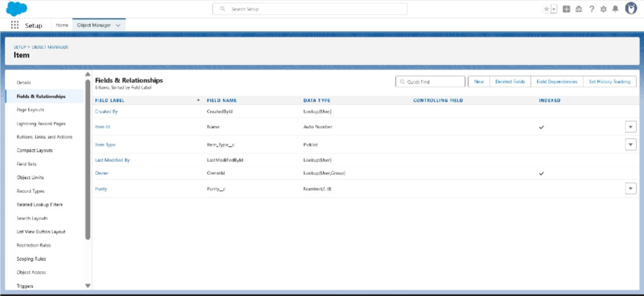

Creating the validation rule - Postal Code & ValidationRule For JewelCustomerObject : Creating the validation rule - ValidationRule For Item :

Gold Smith Profile :

Creating Gold Smith Role :

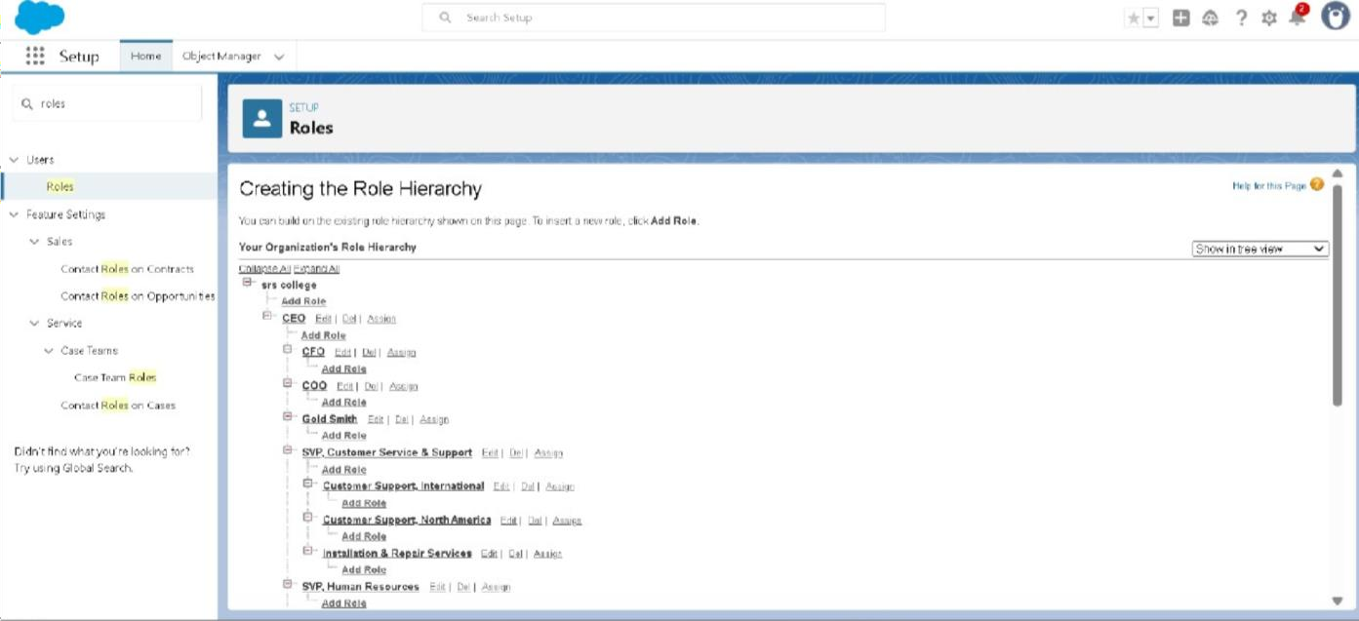

Create User :

To Create Gold & Silver Page layouts :

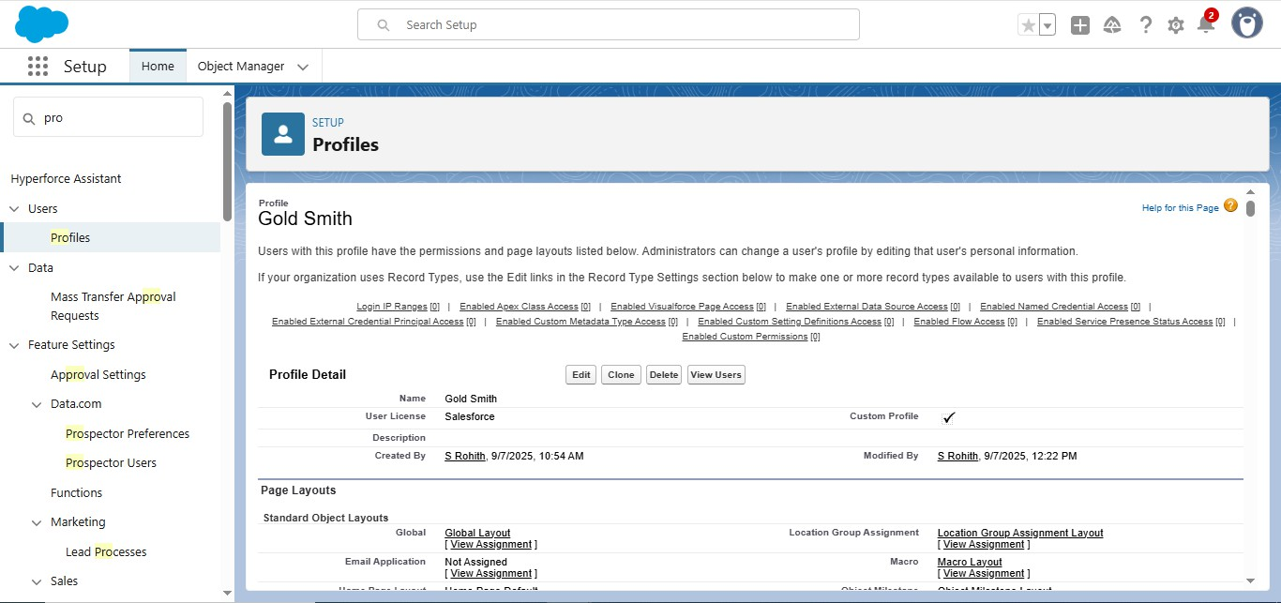

To create a Record Type - Gold & Silver :

Creating permission set :

Create a Trigger Handler class & The Trigger :

Create,View and Delete a Record (Jewel Customer) :

Create Report :

Create Dashboard :

Create a Flow :

Conclusion :

**The CRM Application for Jewel Management successfully streamlined customer interactions, sales tracking, and inventory management for jewelry businesses. As a developer, I focused on building a secure, scalable, and user-friendly system tailored to industry needs. This project enhanced operational efficiency and improved customer engagement. It also laid the groundwork for future features like analytics and mobile support**

